Twi pronunciation
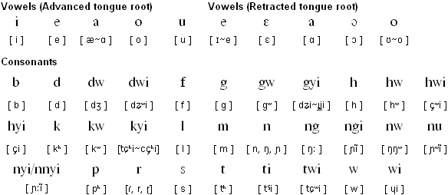

Akan
The Akan languages are part of the Kwa branch of the Niger-Congo languages. There are about 7 million Akan speakers in eastern Ivory Coast, south-central Ghana, and central Togo. There are numerous dialects of Akan, including Twi, Fante, Bono, Wasa, Nzema, Baule and Anyi, with a high level of mutual intelligibility between them.
Akan languages started to be written down, mainly in religious publications, by Danish, German and British missionaries during the 17th and 18th centuries.
There are currently three standardized orthographies for Asante, Akuapem and Fante, there is also a unified Akan orthography which was created during the 1980s.
Akan alphabet
A a | B b | C c | D d | E e | F f | G g | H h | I i | J j | K k | L l | M m
N n | O o | P p | Ɛ ɛ | R r | S s | T t | U u | V v | W w | Ɔ ɔ | Y y | Z z
Letters in italics are only used on loanwords.

Akan pronunciation
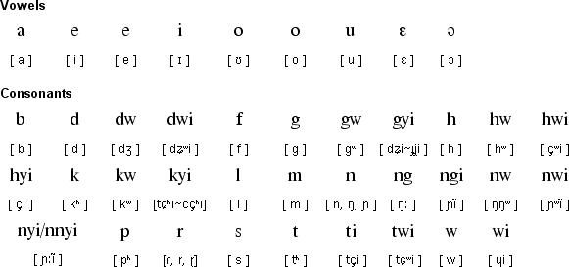

Notes
- There are quite complex rules of vowel harmony governing which vowels can appear in the same word.
- Akan languages are tonal with three tones: high, mid and low.

